**P3 – Identify different types of communication devices**

**Introduction**

In this assignment, I will be identifying different types of communication devices that are available. I will explain data terminal equipment (DTE) and data circuit-terminating equipment (DCE) for wired devices. I will give an example and compare both of them. I will also name the problems and give a solution for it. I will also explain 3G for wireless devices. I will name the advantages and disadvantages with comparison, problem and solution to it.

**Wired Devices**

**Data terminal equipment (DTE)**

Data terminal equipment is also known as DTE. This is a communication device that allows data to be transferred or received with the modem or another piece of device. This device could detect any piece of content that could be transferred or received in this device. This is used in companies and it is important for communication as they do this a lot. DTE also converts signals or reconverts received signals. A DTE device is used with a data-circuit-terminating equipment (DCE) for communication to be enabled.

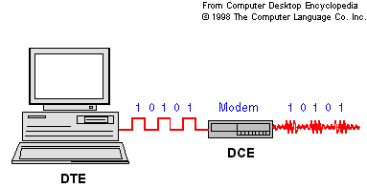

This image shows exactly how DTE works. First, the computer has to send ‘data’ to another network. This works through the modem – converts it – and sends it to another computer that the computer device. DTE and DCE both work together in the process.

**Data circuit-terminating equipment (DCE)**

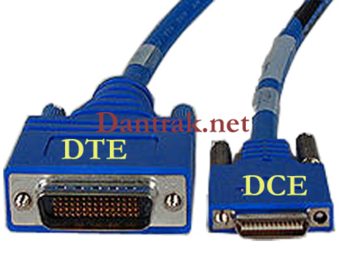Data circuit-terminating equipment also known as DCE is a device that uses analogue and digital signal to be transmitted or received through a network. This works in the physical layer as that deals with the signals. This device helps the user to convert the signals for the communication to be enabled. DTE converts information which helps it on to the DCE device. A common example of a DCE device could be a modem. It is connected with the computer. As you can see above, it converts the DTE information into signals to reach its destination.

This process is used by a cable. The DTE is used for connected with the computer and the DCE is used to connect with the modem.

**Example**

**RS-232C** is an example of DCE. RS-232 is an interface that uses a computer to talk and exchange data with the modem. RS-422 is an example of DCE equipment. DTE uses computers to communicate whereas DCE uses likes of modem to enable communication.

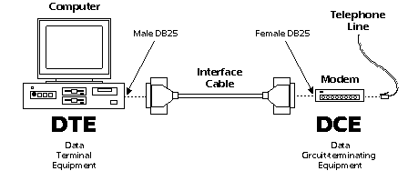

**Comparison**

**RS-232C vs RS-422 devices**

|  |  |
| --- | --- |
| RS-232C | RS-422 |
| * Most commonly used * It has one transmitter and one receiver * Slower to transfer data than RS422 | * This device uses an twisted pair cable to reduce noises * It uses signalling balance to transmit data * Faster data rates |

**Problem & Solution**

The first solution to any problem to communication is that the RS-232 should be checked if it is connected properly. Maybe they might be slightly out of place which prevents it from communicating with another computer. All the user can do is put the wire back to its original position. If it does not work, shut the computer down; put the cable back in and restart the computer. It should work then. Any problems that causes to prevent communication needs to check everything for it to be better next time around.

**Wireless Devices**

**3G**

**3G** stands for ‘third technology’ and it is a connection on mobile technology. It is implemented into mobile phones so that they can be used wirelessly without using Wi-Fi. It depends on the provider – O2, Vodafone or T-Mobile – whether the connection has a good strength or not. The newest mobile technology is 4G. It transmits data faster depending on the provider. The location could affect the signal. If you are in a school, where normally signal is weak, the data transmitted would be slow/or would not work.

**Advantages**

* Download music, pictures and games faster than any other connection e.g. 2G
* Portable – As it is used on mobile phones, you can use the network anywhere
* Quick access to use social networking sites
* Watch movies and keep update with the latest score for any sport

**Disadvantages**

* Cost – Any provider will charge the user to use 3G
* Limited – if the user has 500MB, he/she is restricted to how much internet they use
* Battery goes down quick if they are constantly using the internet

**Comparison**

|  |  |
| --- | --- |
| Wireless | Wired |
| * No use of cable * It can transmit data wirelessly * The user does not need to worry about any wires. If any wires goes wrong for the ‘wired network’, the user needs to fix it, but in this case, he does not need to fix it as they are no wires. | * Easy to set up than wireless connection * Expensive than wireless * Better transmitting any data than wireless. It goes through cables which is faster than wireless. Wireless network the user has to wait as there is signals involved. |

**Problem & Solution**

The second generation was not capable of dealing with very high data being transferred. It was not enough and the only solution to this problem was to bring out another generation which is better than the previous one which is the third generation. The advancement of 3g administrations in the early years of the 21st century was a significant venture forward both regarding dependability and UK scope for voice calls and content informing, and also giving significantly quicker get to the web because of its competence of convey bigger measures of information. The administration permits clients the ability to download a measure of information equivalent to a melody for every moment.